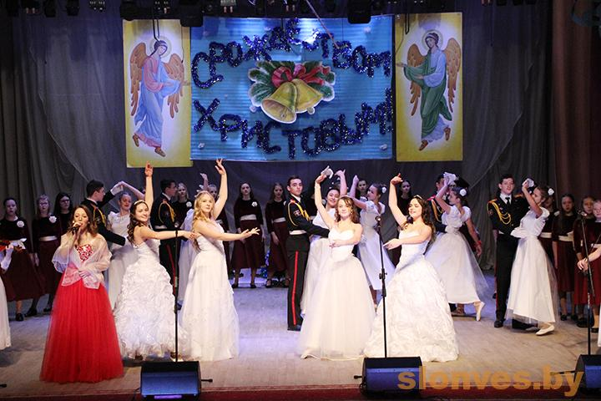
January 12, 2019

State Educational Institution "Slonim Culture and Recreation Center"

District festival "Christoslavy -2019"

The festival is prepared by the education department of Slonim district executive committee together with the clergymen of Slonim deanery. At the end of the festival, the dean of the Slonim church district, Archpriest Vadim Petlitsky, congratulated on Christmas, wished all the best to those present in the hall and handed thanks and sweet prizes to all students who participated in the celebration.
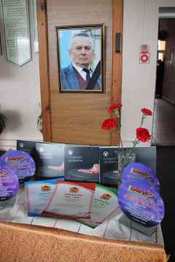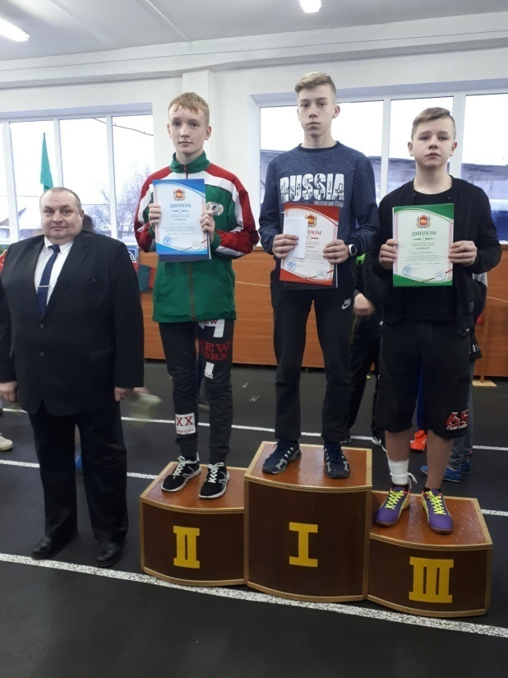
January 11-12, 2019

Open regional competition in memory of Honored coach of the Republic of Belarus G.S. Vilkitsky

In 2008, the first open championship of the Grodno region for the prizes of the Honored trainer of the Republic of Belarus GI Vilkitsky was held in gratitude for the results he achieved in his work. The tournaments were held with the invitation of famous sportsmen-pupils, who were tought by the coach himself. After the death of Gennady Stanislavovich, the competitions were renamed to “Open district tournament in memory of G.S. Vilkitsky ”, his widow was invited, as well as the nephew of the eminent coach Vladislav Vilkitsky, he provides prizes to the winners and awardees of the competitions. The competition involves athletes not only from the Grodno region, but from the whole Republic.
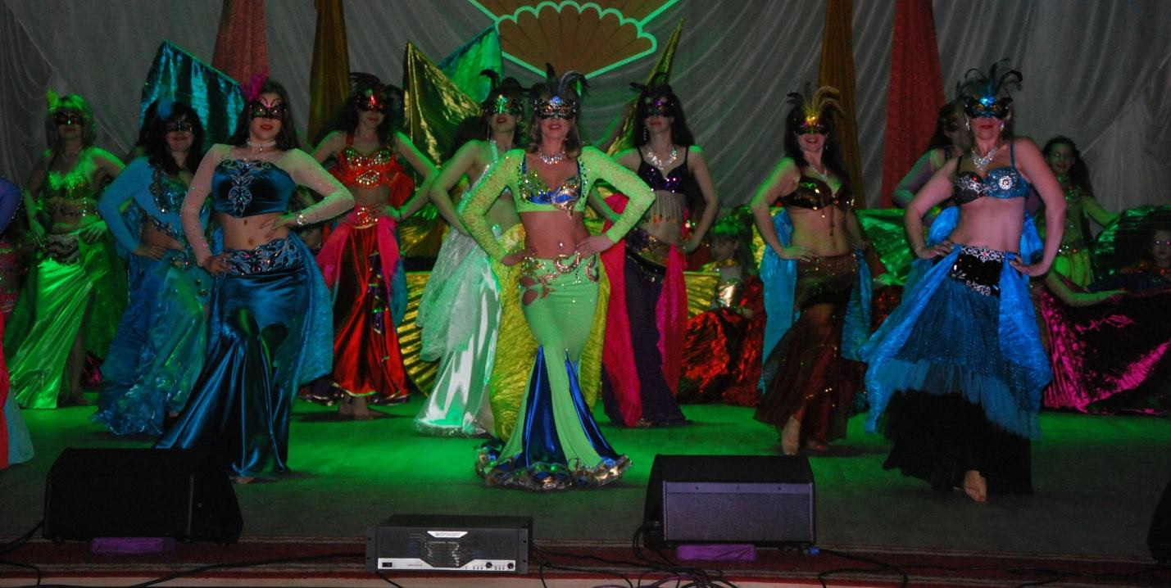 January,13th "Aroma of the East"
III regional show-bellydance festival-contest (Slonim)
The festival-contest "Aroma of the East" is an enchanting show filled with bright, colorful performances of the participants of the studio of oriental dance "Leila", created in the technique of bellydance.
The program includes: competitions, a performance of soloists of Slonim Center of Culture and Recreation, an entertaining program for children, awarding of participants of the contest program.
Phone: +37501562 618 64

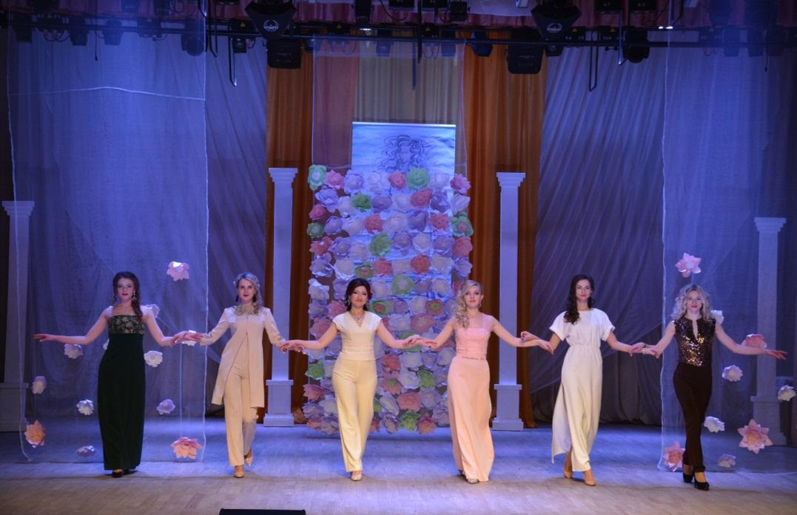 February, 2d
"World of Dreams"
Show program of the fashion theatre "Etoile" (Slonim)
The show program of the people’s theatre of fashion "Etoile" is a real feast of beauty, grace and femininity.
The program includes: demonstration of new collections, a concert program of soloists of the pop studio "Kameya" of the State Cultural Institution "Slonim Center of Culture and Recreation", presentation of the photo exhibition "Beauty has a Woman's Face" of the People’s Film Studio of Slonim Center of Culture and Recreation, photo zone "ProFashion", a master class from the hairdresser's "Empire".
Phone: +37501562 618 64
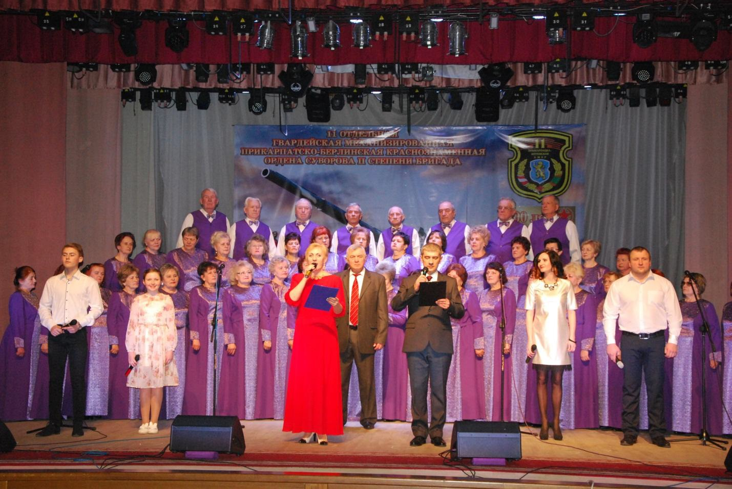 February, 22d
"The Holy cause is to serve the Motherland!"
The holiday is dedicated to Motherland Defender Day and the Armed Forces of the Republic of Belarus (Slonim)
This holiday is a series of events dedicated to Motherland Defender Day. The program includes: an exhibition of modern weapons, an exhibition of military uniform of different countries of the world, a parade concert of the military brass band led by Major R. Yatsyna (military unit 33933), a festive ceremony of rewarding, a festive concert of the best amateur groups of Slonim. Phone: +37501562 618 64

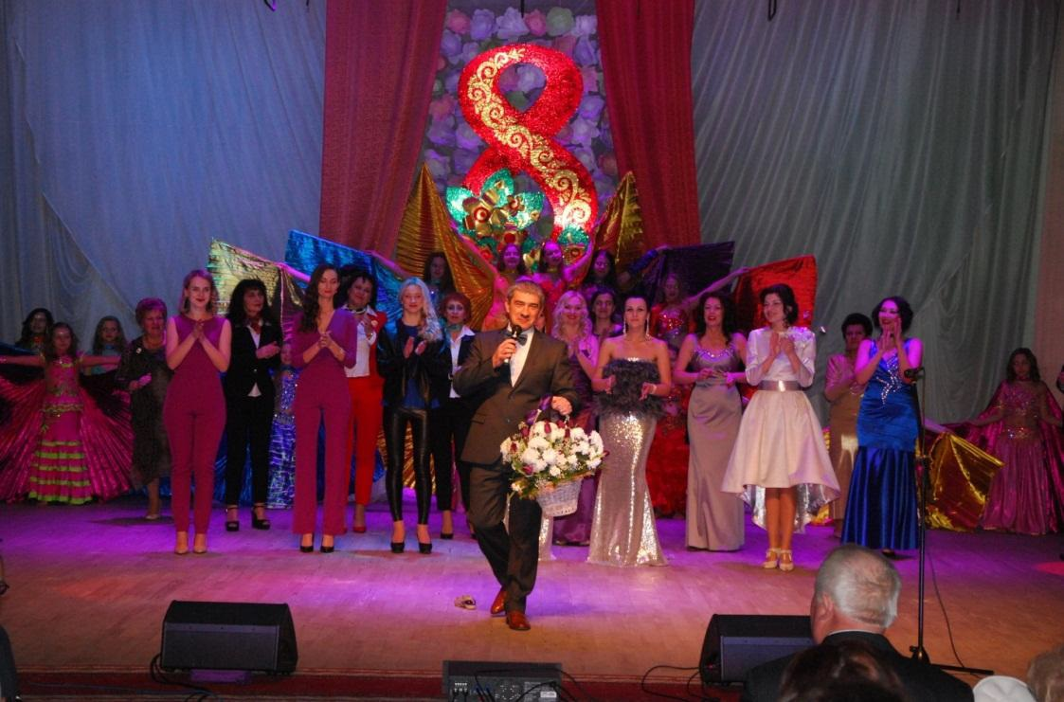 March, 7th
Festive concert "Woman, you are the beginning of all beginnings!"
(Slonim)
Actors and creative groups from Slonim Center of Culture and Recreation will present warm atmosphere, extraordinary numbers, new songs, good mood, congratulations and flowers for the beautiful half of humanity on this spring day.
Phone:+3750156250636
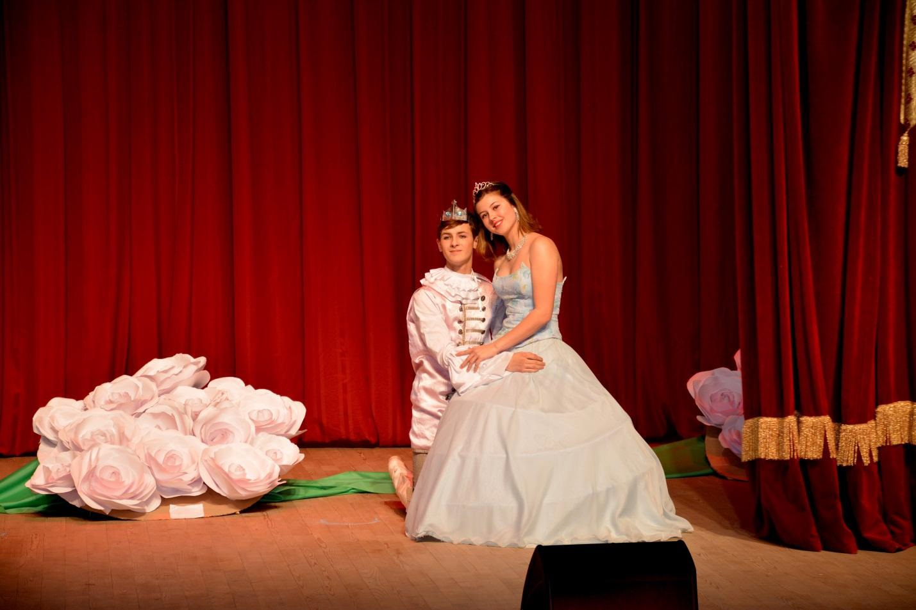 April
Regional festival of children's exemplary theatrical collectives "Slonimskytsudadzeistvy" (Slonim)
Slonim Center of Culture and Recreation will hospitably open its doors for the best exemplary theatre groups of the region for the twelfth time. It is very significant for us that the event is held in Slonim, where theatrical traditions have survived up to nowadays. The residents and guests of the town will have a unique opportunity to get acquainted with theatrical productions of national and world drama, in the Belarusian and Russian languages. The festival will begin with a bright opening, then there will be bright performances and at the end there will be the procedure of awarding of the winners.
Phone: +37501562 618 64

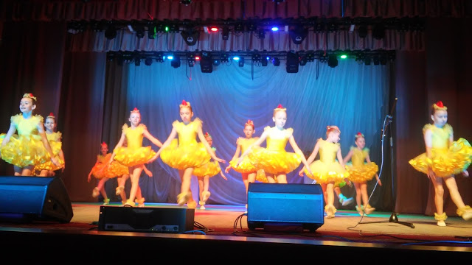 March, 26th
  - Grand opening of the Children's book Week "The world is kinder and brighter with a book!"
Visitors of the festival will have an amazing adventure into the world of books, a meeting with a modern Belarusian writer, they will see the performances of children's musical and dance groups, it will be possible to participate in literary quizzes and games.
Slonim, Krasnoarmeyskaya str., 25 (The town children's library, The district children's library)
Tel. (801562) 5-06-59, (801562) 6-22-40
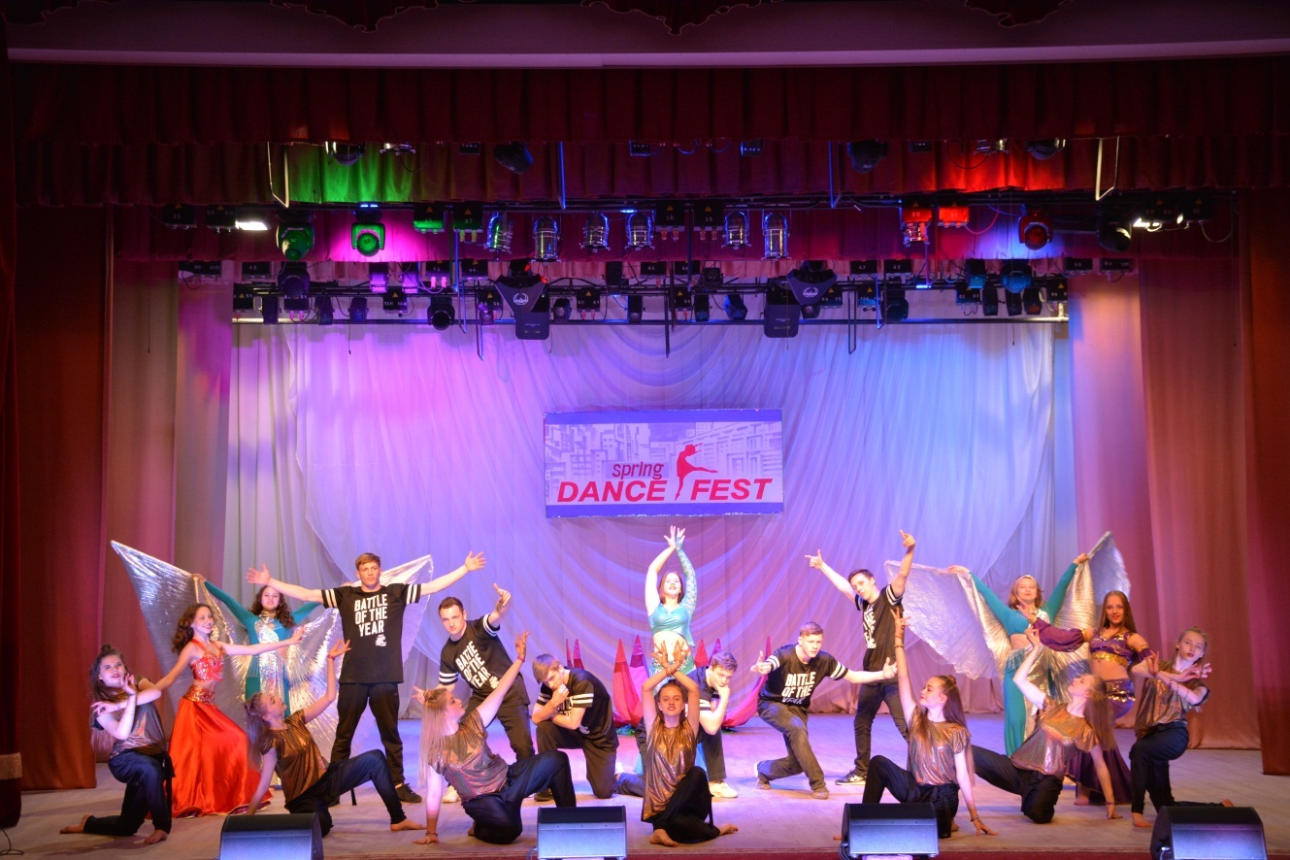 April, 27th
III district open dance festival "Spring Dance Fest" (Slonim)
The third district open dance festival "Spring Dance Fest" will be held on the eve of the International Day of Dance in Slonim Center of Culture and Recreation. Dance groups of various choreographic orientations will take part in the festival in the following nominations: folk dance, pop dance, modern choreography, oriental dance and oriental solo dance. Participants of the festival will come from many towns of Grodno region .
Phone: +37501562 618 64

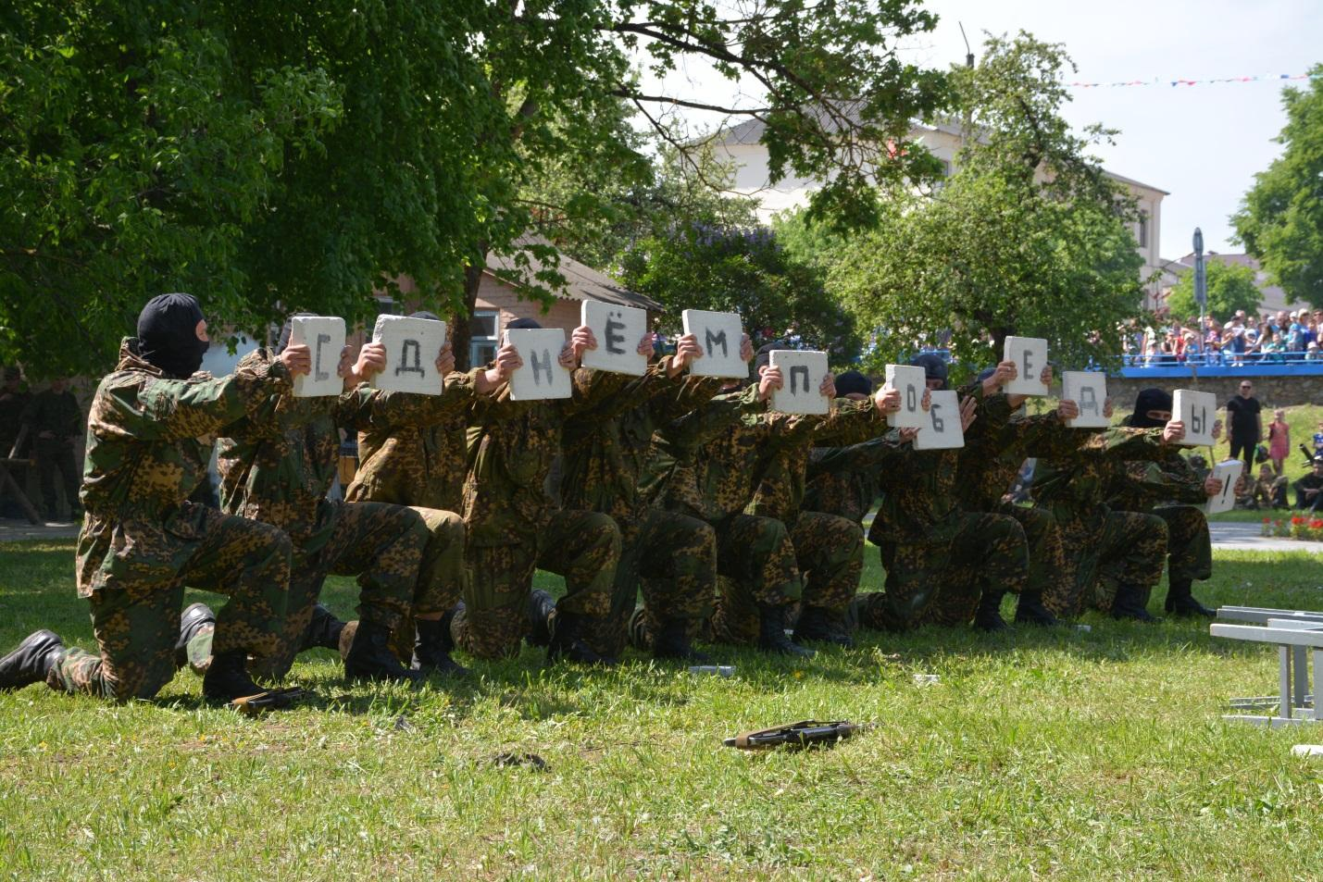 May, 9th
Festive events, dedicated to the Victory Day (Slonim)
Victory Day is a holiday of memory and pride for each resident of Belarus. The holiday program includes:
- a meeting "The holy memory of past",
- a people's festival "Heart remembers and never forgets!",
- a festive concert "Let's sing about spring and victory!",
- sporting competitions,
- playgrounds,
- attractions,
- festive fireworks,
- a republican action "Let's sing" Victory Day "together!".
Phone: +37501562 50636

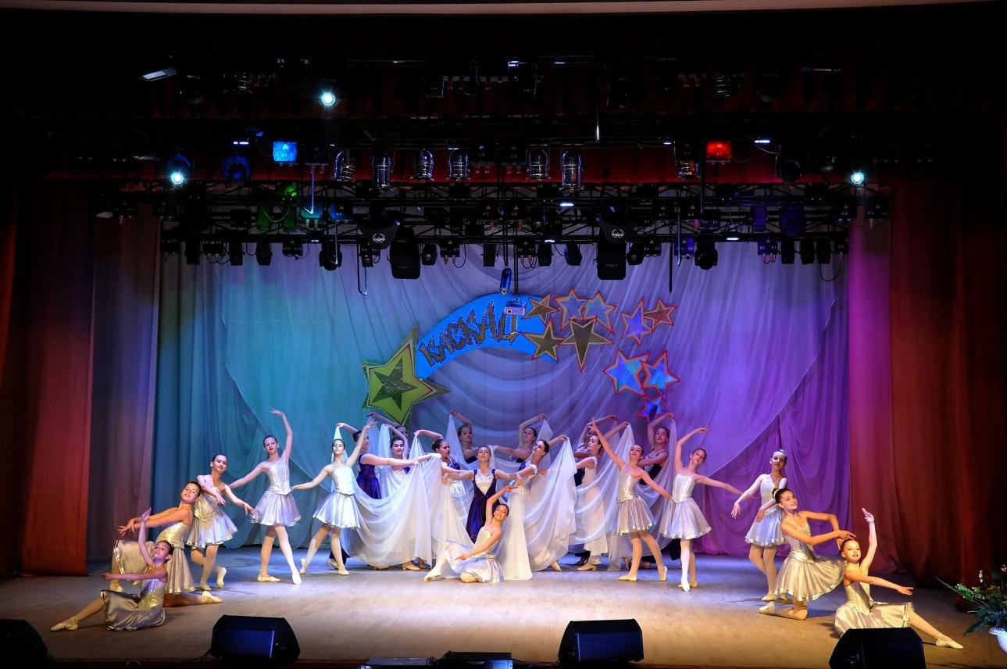
May, 17th
A reporting concert of the exemplary theatre of pop and sporting dance "Cascade" "Meeting the" Cascade "
(Slonim)
The exemplary theatre of pop and sporting dance "Cascade" is characterized by stable creative activity, high artistic level of concert programs and performing mastery. Each performance of the collective is a bright event, a fairytale theatre, an unknown story, a magical image: diverse, unique, always amazing and mysterious.
Phone: +37501562 5 0536

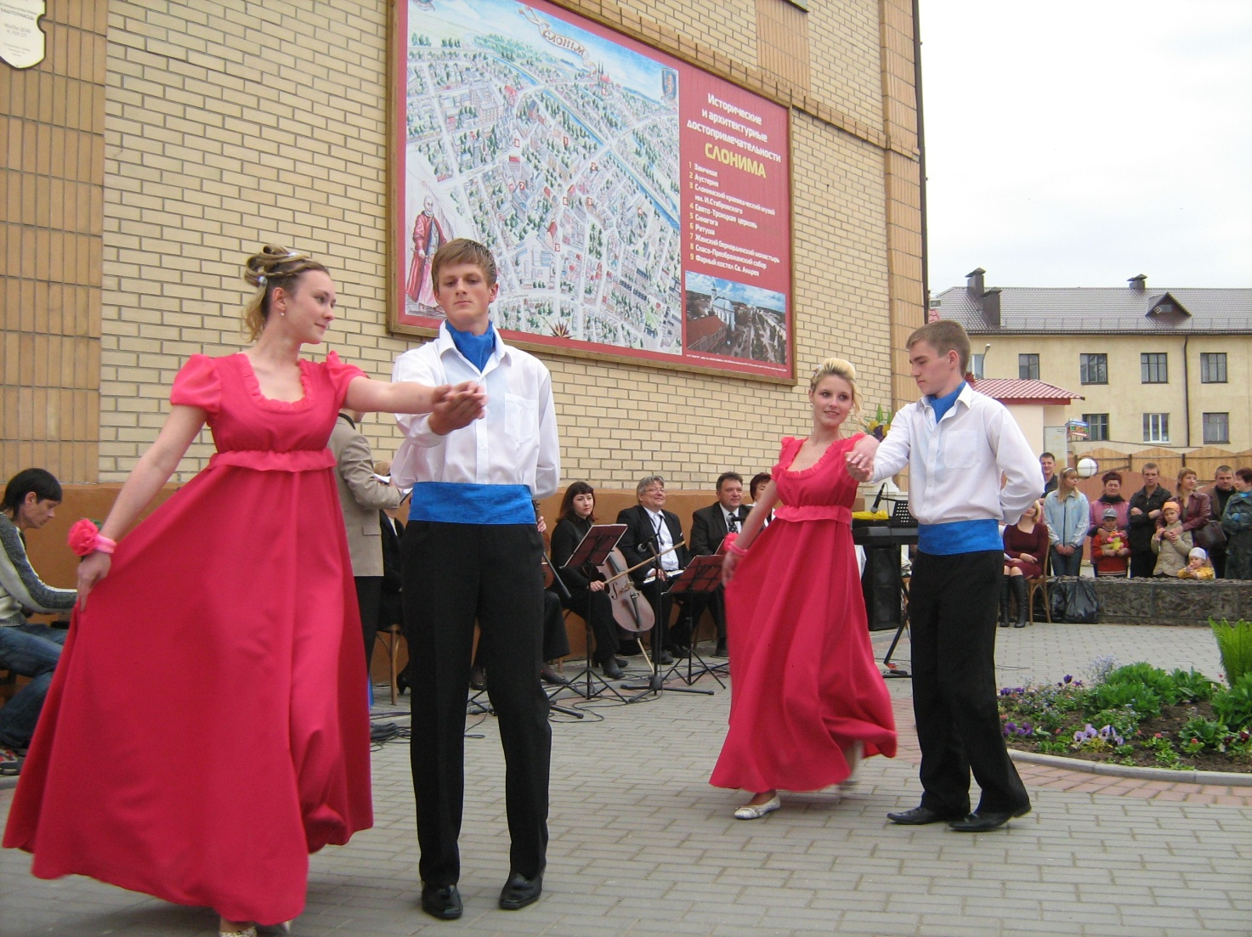 May, 18th
“Museum night – 2019”
Slonim, Lenina sq.,1
The action is devoted to the International museum’s day.
The program will contain: a concert on the ground before the museum, a presentation of the exhibition “Golden arms of she-master”, workshops, an interactive program for little museum visitors “In the world of a fairy tale”, food “like in Slonim”, a hyper-quest “Museum snoop”, a meeting with the Slonim residents Yakubenko - the family of builders - “In the spirit of soviet times”, a win-win lottery, etc.
Теl.: +375 1562 6 34 10

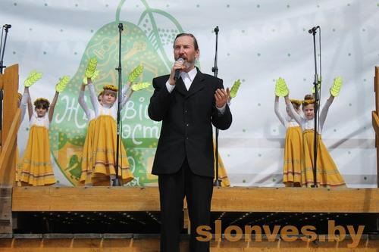
May 20
Open air Festival «Zhirovichi Fest» (Slonim district, agro-town of Zhirovichi, area at the old spring)
The festival «Zhirovichi Fest» is held in honor of the celebration of the phenomenon of the icon of the Mother of God Zhirovichskaya. Choral collectives, vocal groups, solo performers from all over Belarus take part in the festival. The aim of the festival is the revival and preservation of spiritual traditions, the popularization of the spiritual heritage.
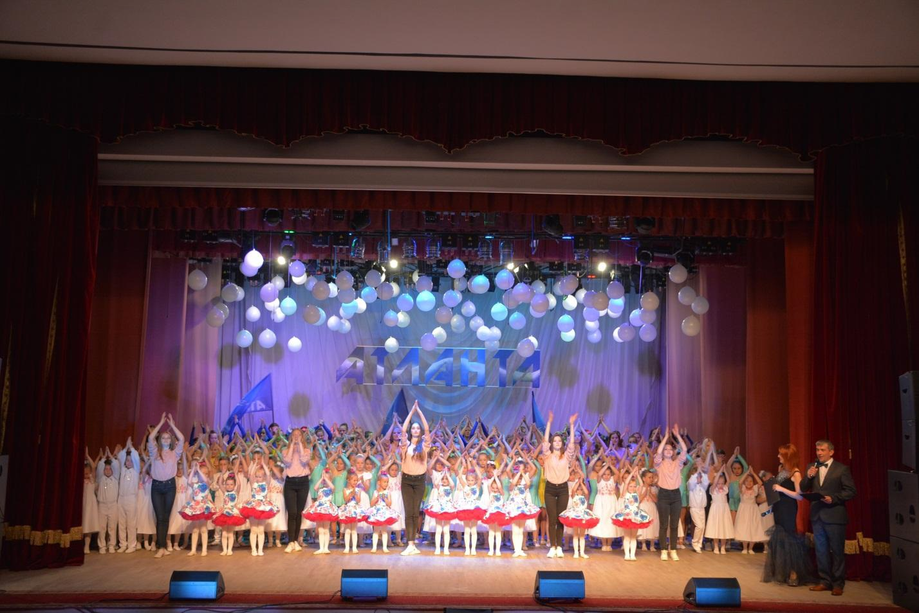

May, 24th
A reporting concert of the exemplary ensemble of modern dance "Atlanta" (Slonim)
The exemplary ensemble of modern dance "Atlanta" is a warm and cozy house, which doors are always open for children. The collective engages a large and diverse group of children united by love to dance. The exemplary ensemble of modern dance "Atlanta" allows to feel the nature of dance, its beauty and uniqueness.
Phone: +37501562 5 0536

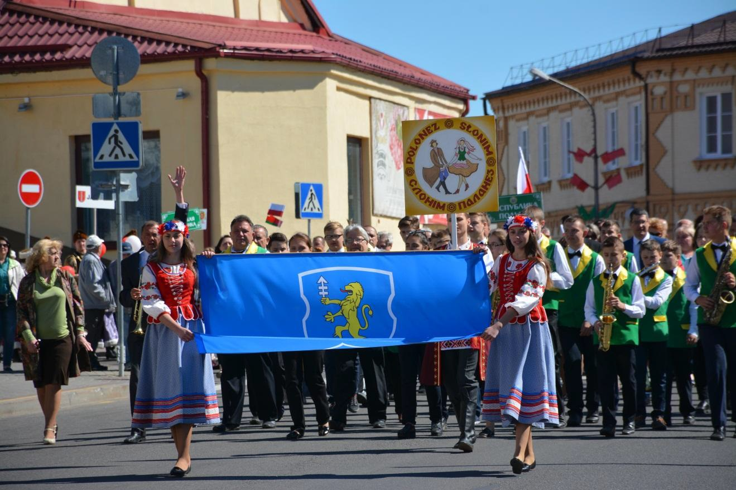 May, 25th
Open Regional Festival "Polonaise-2019" (Slonim)
For the fifteenth time Slonim will wait for visitors from Belarus and neighboring countries (Poland, Lithuania, Latvia, etc.). In the period from 2005 to 2018 Slonim has met more than 280 collectives.
Participants of the festival will perform in the contest, which consists from two parts: performance of the polonaise and a free program. In the contest program the polonaise will be performed in various categories: vocal choral genre, instrumental genre, choreographic genre. All the collectives will also present a free program to the spectator's court.
Phone: +37501562 50636

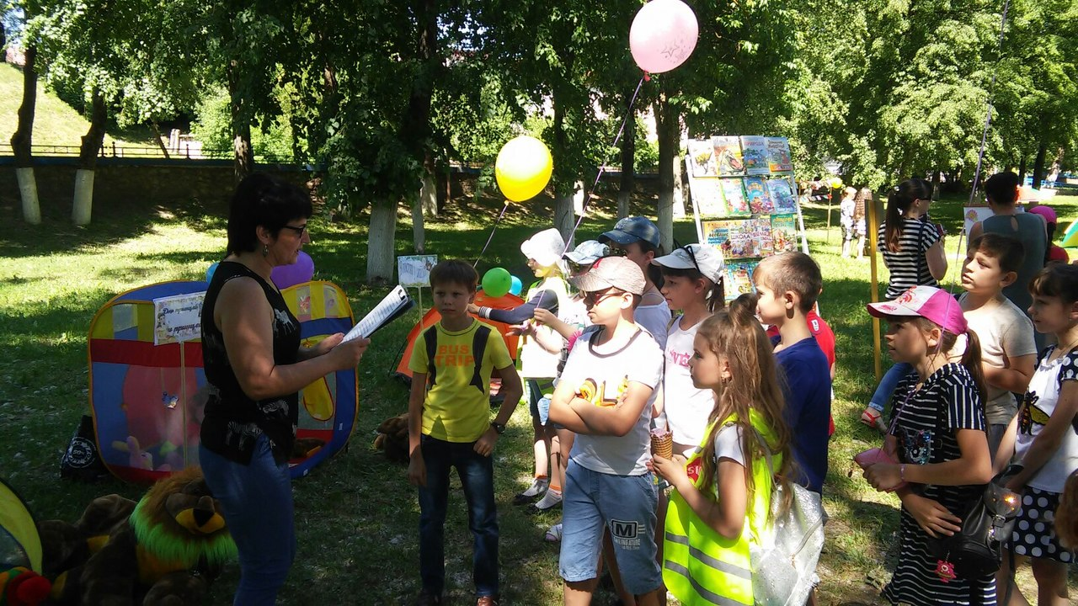 June, 1st
  - Meeting at the Library yard "Summer reading is a real adventure»
On the International children's day residents of the town and the district, children and young people will have a possibility to visit various library grounds in the open air in the Slonim town park. They will see a lot of book exhibitions, take part in the improvised games, look at the performances of the puppet theatre “The sun", literary quizzes and competitions, games and entertainment.
Slonim, Opernaya str.
Slonim district library named after Yakub Kolas
Tel. (801562) 5-06-76, (801562) 5-06-54

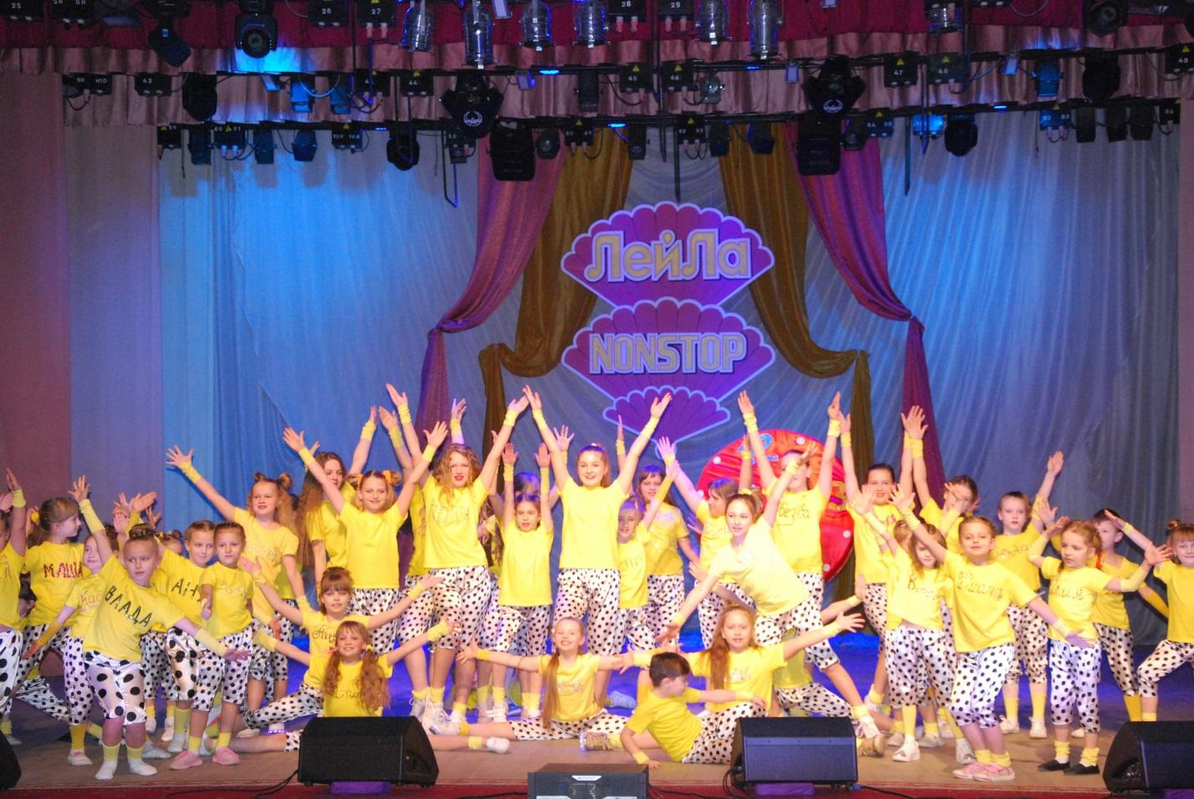 June, 2d
The reporting concert of the dance studio "NonStop" and the studio of oriental dance "Leila" (Slonim)
More than 10 years Slonim spectators get pleasure from the performances of the dance studio "Leila". Unforgettable enchanting spectacle with a note of the east will be presented on this day by the members of the team in the program "EasternFairy-2019". No one will be indifferent to the children's dance studio "NonStop". The participants of the studio will delight the audience with bright suits and incendiary dances.
Phone: +37501562 618 64

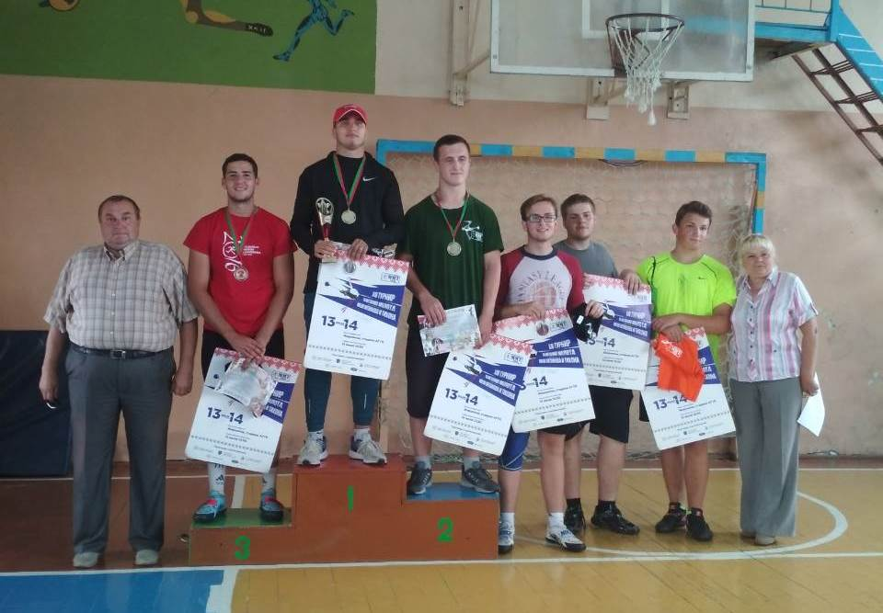
11-13 July 2019
XIV regional competitions for the prizes of the Honored Master of Sports of the Republic of Belarus IG Tikhon.
Slonim region is famous and proud of its Olympians. In 2004, our compatriot, World Champion and World Universiade 2003, Ivan Tikhon ascended the Olympic peddistal. He became the silver medalist of the 28th Olympic Games. In honor of the name of the sportsman-pupil of our school in 2006, regional competitions were organized for the prizes of the Honored Master of Sports of the Republic of Belarus IG Tikhon.
Meetings were organized not only with Ivan Tikhon himself, but also with his parents. Not only Belarusian athletes come to show their sports skills, but also guests from Russia and Poland. Not only experienced athletes take part in the competition, but also young athletes from all over the Republic and foreign countries.
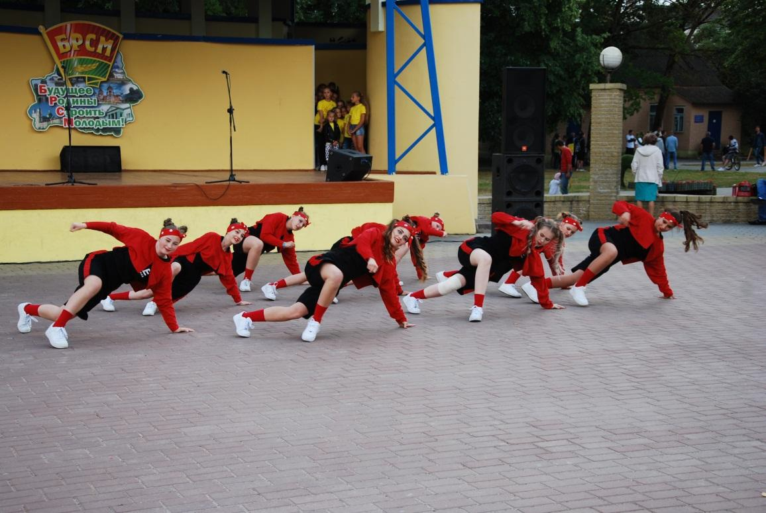 June, 30th
The youth holiday "Territory of drive in bright format" (Slonim)
The event will bring together the brightest, youngest and the most creative performers and collectives of Slonim. Gyroscope lovers will take part in the races "Forward, transport of future!" The most desperate and brave girls will participate in the "Labutena-2019" heels race. Photo-zone and photo-drying will also be organized. At the end of the holiday there will be a festive disco.
Phone: +37501562 50636

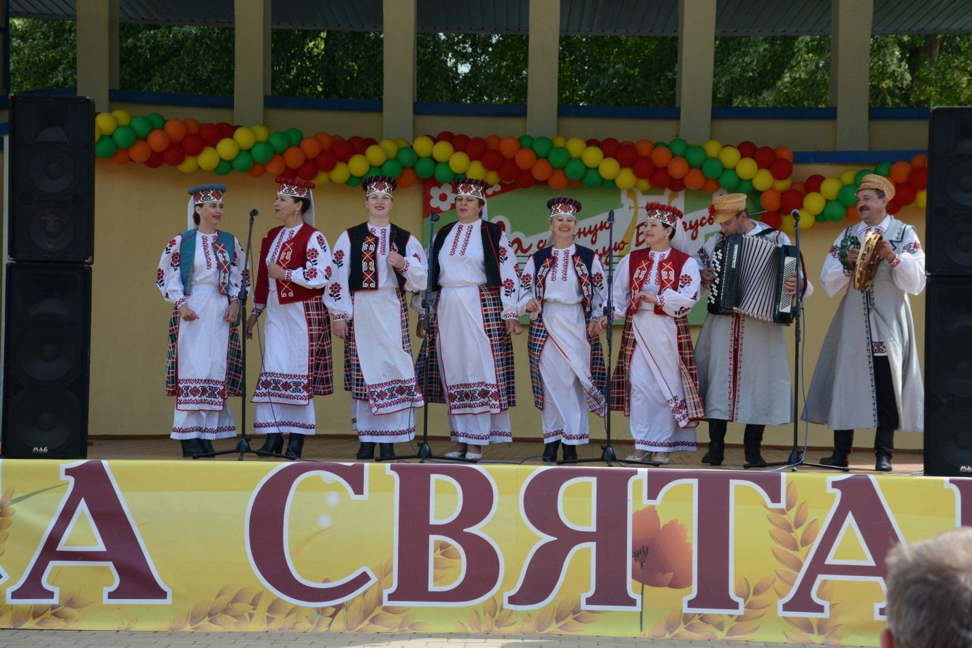 July, 3d
Festive events dedicated to the Independence Day of the Republic of Belarus
"We are praising your name, Belarus!"
The celebration of the Independence Day in Slonim district includes a complex of cultural, sporting, entertaining, patriotic, informational events. There will be: a meeting-requiem "Nobody is forgotten, nothing is forgotten", holiday concerts with the participation of creative teams and performers, game programs, sports, contests, exhibitions of arts and crafts, a festive trade. A large concert of professional and amateur creative groups will take place on the central square. The traditional action "Sing the hymn together" and the festive fireworks will become a culmination of the evening program.
Phone: +37501562 50636

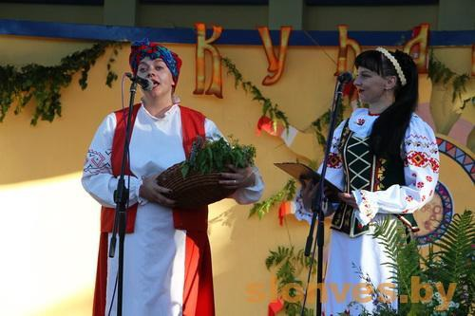 July, 7th
Folk festivities "Kupalie"
(Slonim)
The festival program includes: a theatrical performance, the lighting of a bonfire, an ethnic encore "Searching the paparats-kvetka", folk games, a sporting competition on swimming, a master class on wreathweaving, letting the wreaths swim in the local river, fountains on the water, a concert of amateur musical collectives, sporting power competitions, a sale-exhibition of crafts, disco dances, amusing attractions.
Tel. 8 (01562) 5 0176

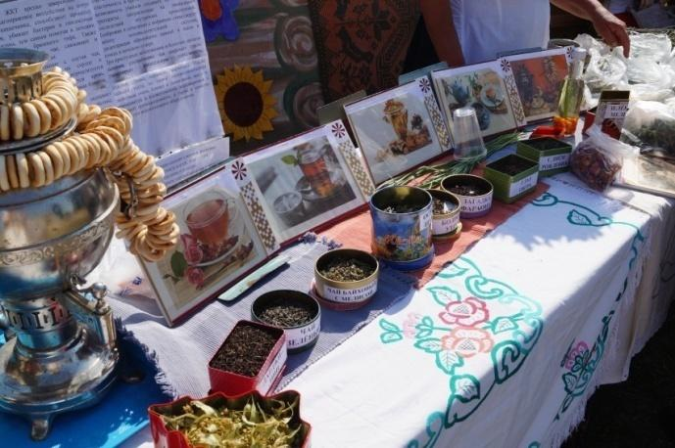 August, 11th
Holiday of honey and tea
(Slonim district, ag.Vasilevichi)
Beekeepers and herbalists are invited to the festival. There will be a fair-sale of bee products and medicinal herbs. Visitors will be able to taste different sorts of honey and herbal tea. Spectators will be able to take part in thematic quizzes, games, competitions. Entertaining attractions will work throughout the holiday.
Tel. 8 (01562) 5 01 76

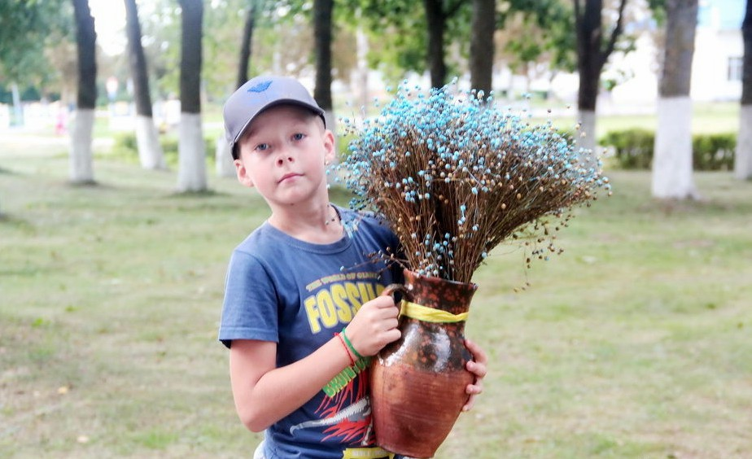 August, 11th
Flax Festival “Blakit Nyabes”
At the Flax Festival in "Mizhevichi" it is planned to award the best flax producers of the farm. There will be held the following contests: on the processing of flax, on the best culinary product using flax seed. There will be organized exhibitions of folk art, arts and crafts. Local beauties will prepare a fashion show of flax. At the end of the holiday a concert of amateur art groups will be held.
(Slonim district, sub-territory of the branch “Mizhevichsky center of culture”).
Тел. 8(01562) 5 01 76, 8 (01562) 92 2 74

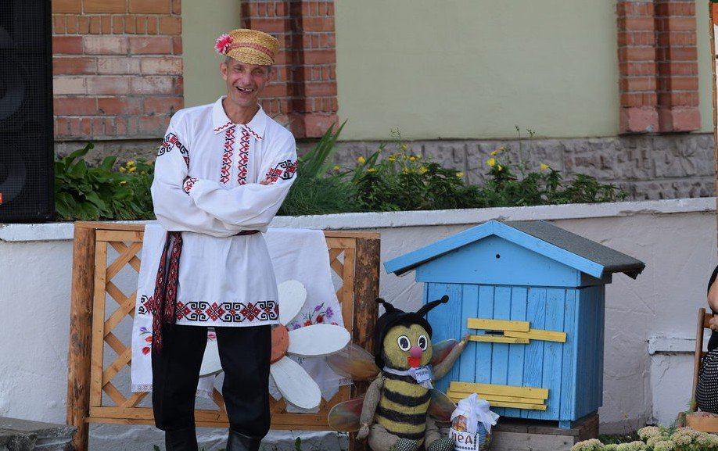 August, 18th
Beekeepers and gardeners feast
(Slonim district, ag. Senkovschina)
The holiday combines elements of the Honey, Apple and Nut Savior. There will be a fair of honey and beekeeping products, products of gardening, a concert of amateur groups, a game program "Spasauskija zabavy", an exhibition-sale of folk arts. Visitors will taste sorts of honey, nuts, apples, pears, take part in master classes of local beekeepers. Entertaining attractions will work throughout the holiday.
Tel. 8 (01562) 5 0176
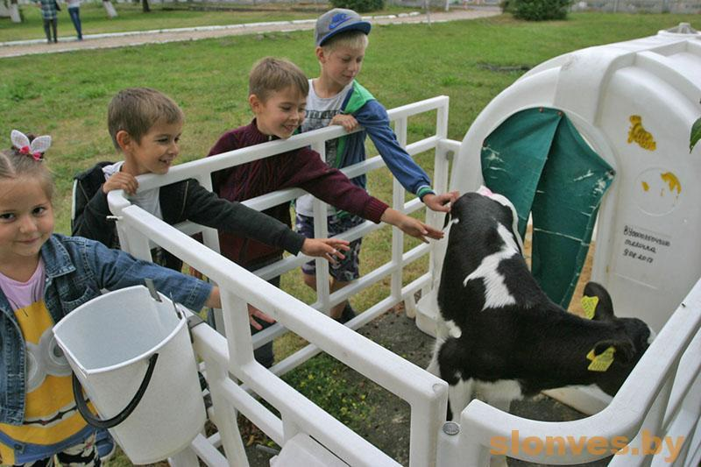 August 25
Milk holiday «Milk land - the paradise for people» (Slonim district, the village Surinka)
The guests of the holiday will taste milk and milk products, take part in the contests «Who will milk a cow faster?», «The best milk dish», exhibitions of decorative applied arts, quizzes, entertaining programs, the concert of amateur collectives. For young participants there will work a playground and other attractions. The best workers of milk farms will get prizes at the holiday.
Tel.: 8(01562) 50176, 63591

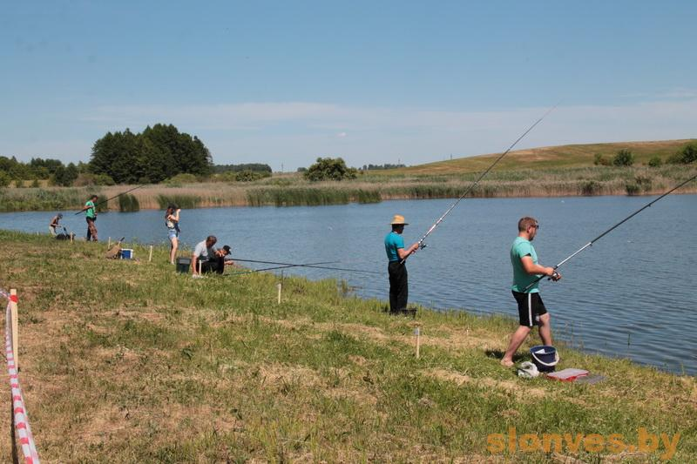 August,25-th
Fisherman's holiday
(Slonimsky district, ag. Drapovo, ground near the lake)

The holiday will take place on the territory of Ozernitsky village council and it will involve lots of different competitions: for the best catch, for the biggest fish, for better bait, for the best fishing gear. An exhibition-contest for the best culinary product from fish will be held. Guests of the holiday will be able to enjoy a delicious, rich and fresh fish soup. Private fishing goods stores will be invited to present the novelties of fishing equipment. Collectives of amateur creativity organize a concert program for the participants of the festival.
Tel. 8 (01562) 93 5 46, 8 (01562) 5 01 7

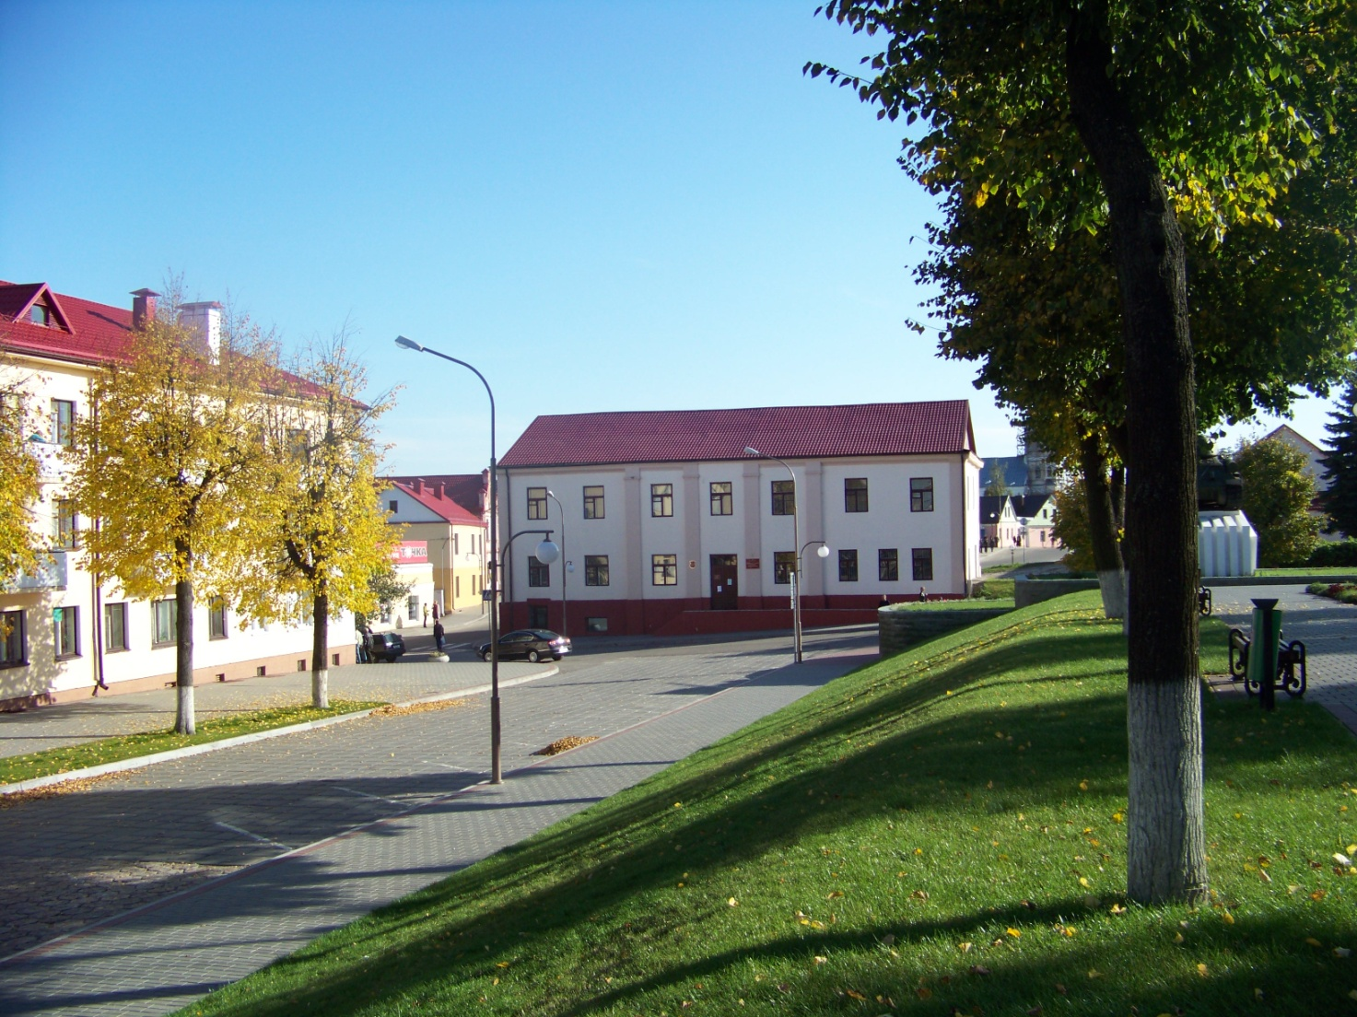 September, 1st
  - “ Yakub Kolas readings” devoted to the 75th anniversary of Slonim district library named after Yakub Kolas.
The celebration will take place during the national holiday -- the day of Belarusian writing. “Yakub Kolas readings” will invite the granddaughter of Yakub Kolas Vera Danilovna Mitskevich, Belarusian writers, historians, journalists and amateurs of the literary heritage of Yakub Kolas.
Slonim, Sovetskaya str, 6
Slonim district library named after Yakub Kolas
Tel. (801562) 5-06-76, (801562) 5-06-54

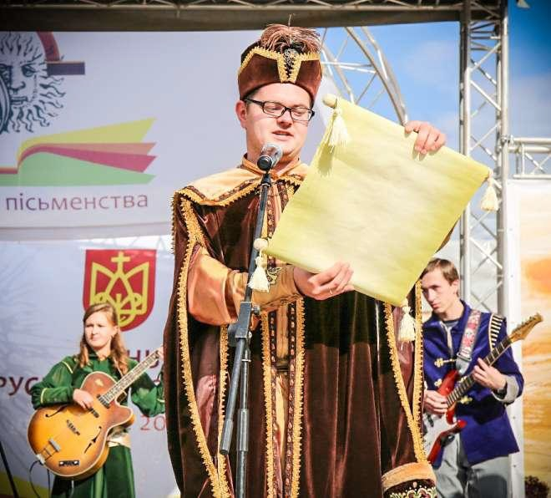 September, first Sunday
Annually in our republic National Day of writing and printing is held.
On the first Sunday of September, 2019, the republican holiday of national writing and printing will be held in Slonim. The concept of the holiday is so that it is important to show the unity of Belarusian literature and printed word with the history and culture of the Belarusians, the holiday reflects the historical path of writing and printing in Belarus.
Phone: +37501562 50636

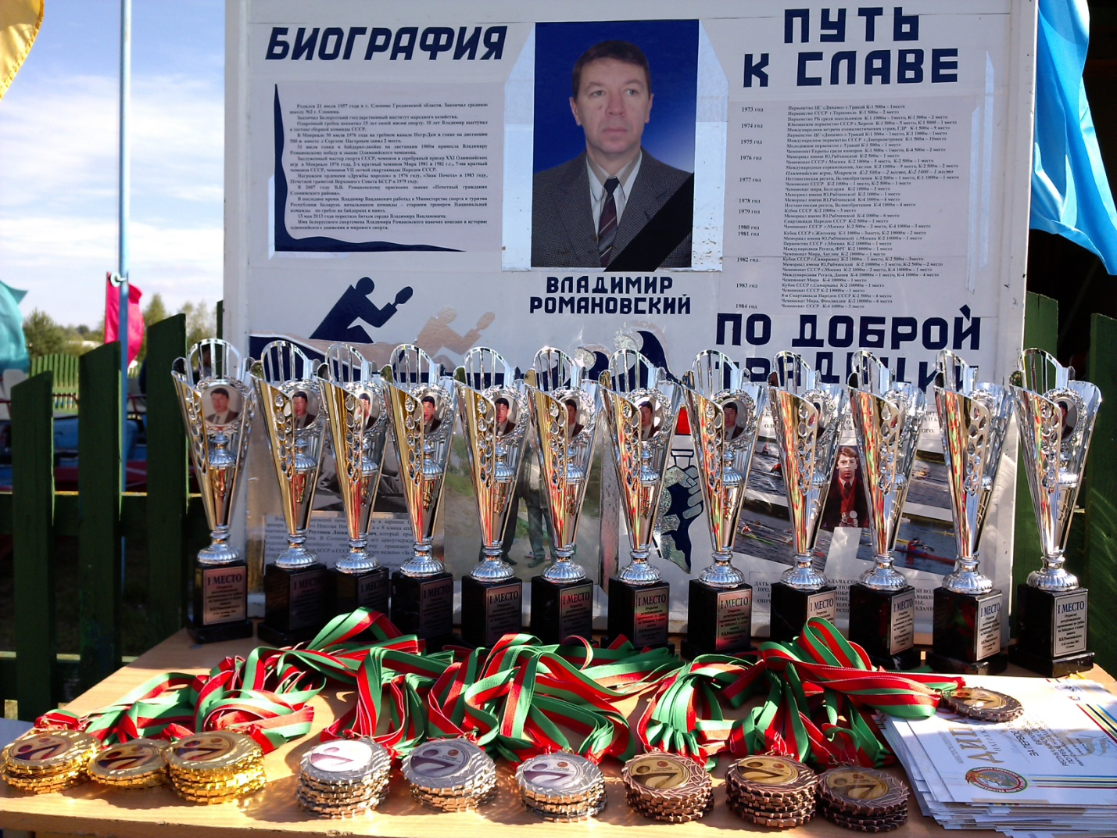 September 19-21, 2019, Republic of Belarus, Grodno region, Slonim, Lake “Tekstilshchik”

Open Republican competitions in rowing and canoeing in memory of Olympic champion V.V.Romanovsky

A unique event associated not only with competitive activities, but also with the development of international relations, the formation of a commitment to a healthy lifestyle, and countering doping in sport.
The program of the event: the grand opening of the competition; races for 200 meters and 2000 meters; awarding winners and medalists with medals, diplomas, cups, personal prizes; Visit to the Holy Dormition Zhirovichsky Monastery.
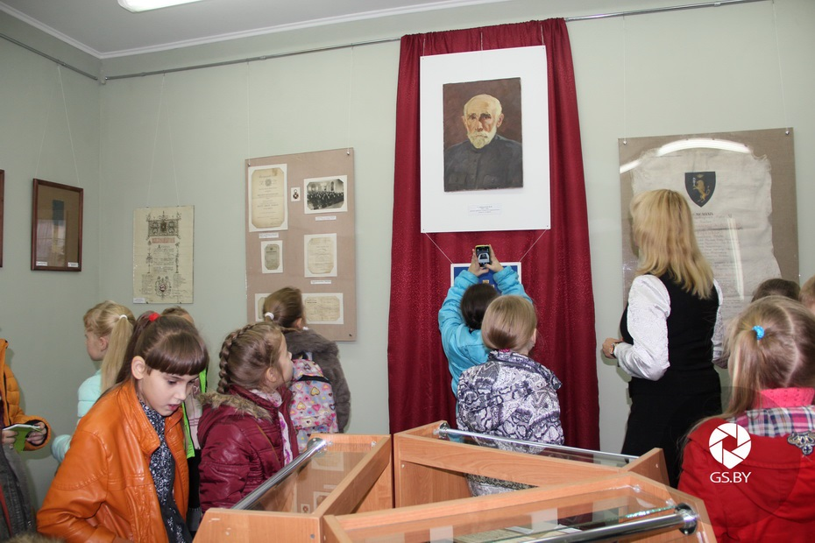 September, 20th
“Celebrating your birthday, Museum!” Slonim, Lenina sq.,1

The action is devoted to the 90-th anniversary of Slonim district museum of the local history.
The program will contain: a holiday concert, a presentation of the exhibition from museum funds “Slonim riches”.

Тел.: +375 1562 6 34 10

September, 28
The “Paulausky Karavay” Festival (Slonim district, Pavlovo village)

The festival is held like a thematic event devoted to preservation and promotion of the intangible cultural heritage of Slonim region. The peculiarity of Slonim “karavay” is сlosely related to local traditions and goes with accompaniment of songs, jokes, sayings, which women, baking the “karavay”, store in their memory with the same trepidation as the recipe itself. The holiday will be dedicated to the guest “karavay”. The holiday program includes: concert of folklore groups, exhibition-tasting of “karavays” of Slonim region.
Tel. 8 (01562) 5 0176

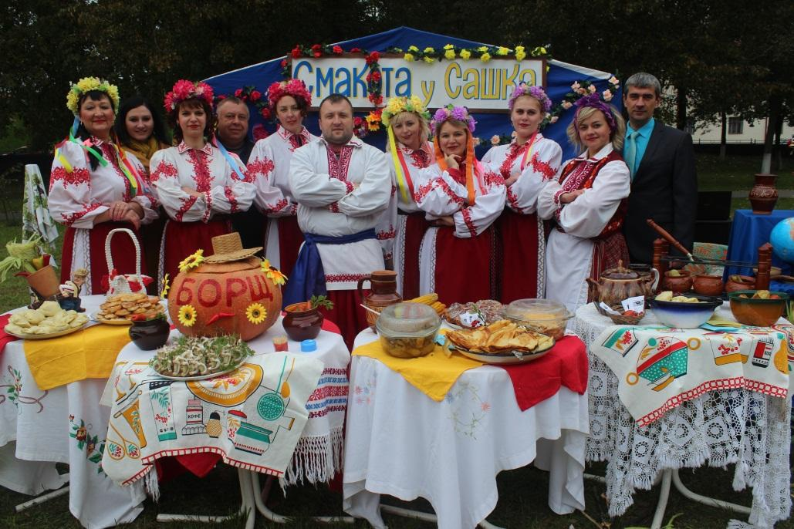 October, 6th
“Friendship without borders”
IV regional festival of Slavic creativity (Slonim)
This festival-holiday unites all the national diasporas living in Slonim region. The event will traditionally begin with a costumed procession of representatives of all diasporas. By the territory of the town park lots of thematic farmsteads will be located. Everyone can get acquainted there with the peculiarities of the national cuisine of the people. Throughout the holiday songs of all ethnic groups will sound.
Phone: +37501562 50636

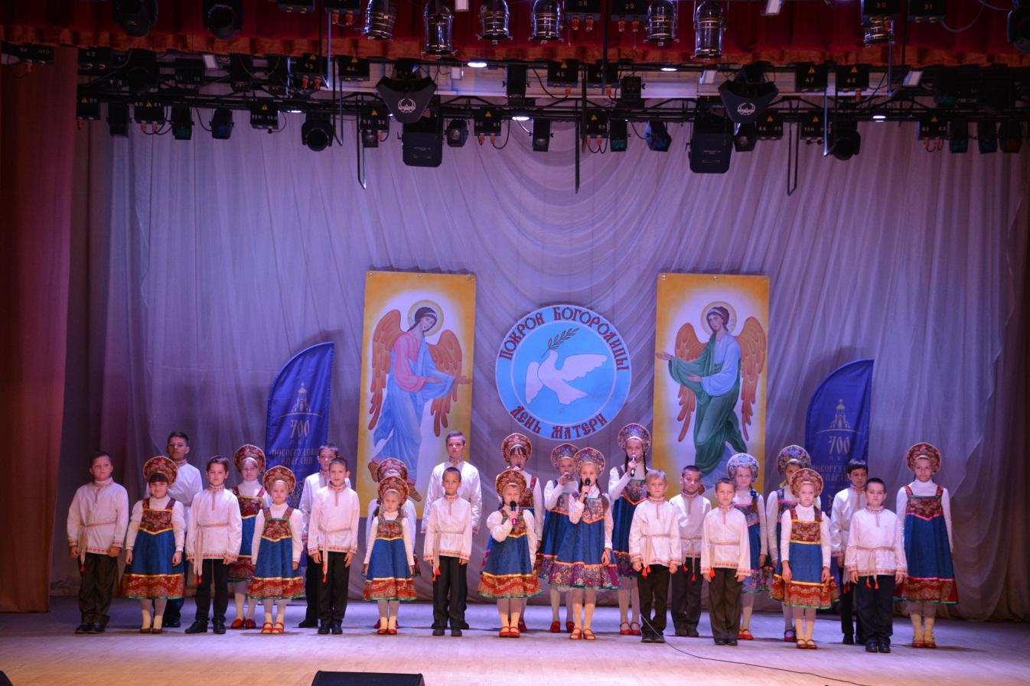 October, 14th
Festive event dedicated to Mother's Day "Heart filled with love" (Słonim)
In the middle of autumn, close to the great Orthodox holiday of Protection of the Holy Virgin Belarusians celebrates Mother's Day. Traditionally in Slonim in honor of the icon of the God’s Mother "Sporuchnitsa greshnyh" the pupils from the parish will show a theatrical performance and concert numbers for the closest and dearest ones.
Phone: +37501562 50636
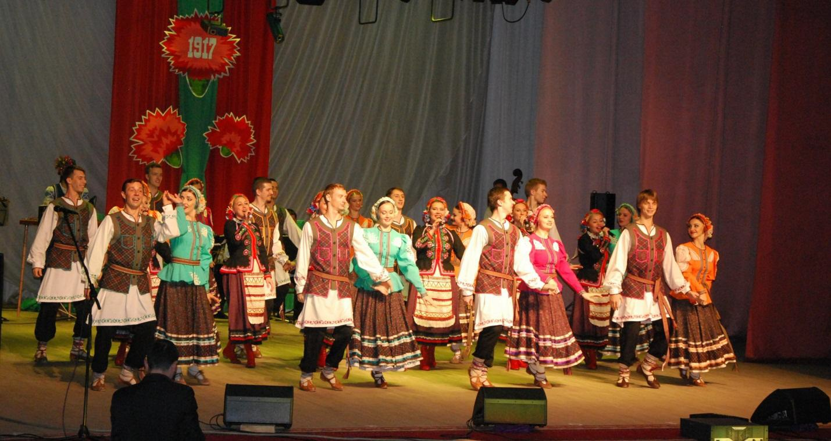 November, 7th
Festive event dedicated to the Day of the October Revolution "This Day is in the History of our Country" (Slonim)
This year Belarus will celebrate the 102-d anniversary of the October Revolution. In the festive concert program the best creative groups and soloists of Slonim region will take part.
Phone: +37501562 50636

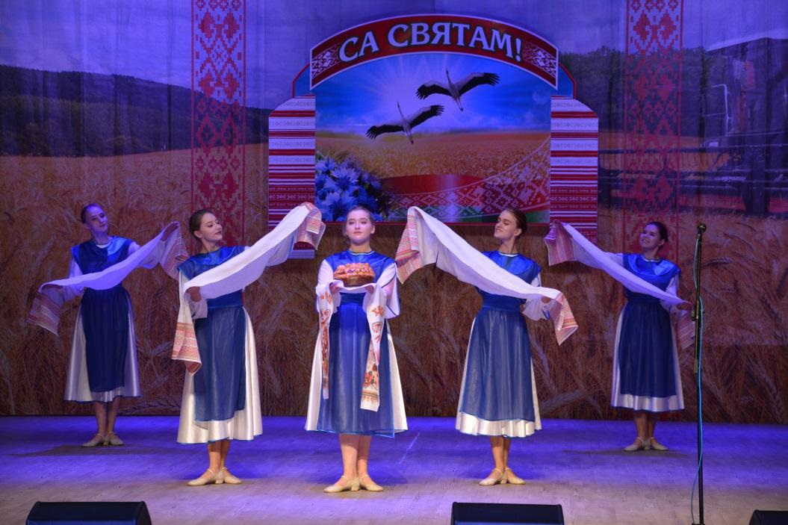 November,15th
"We’ll have bread – we’ll have a song!"
The festive event (Slonim)
This wonderful holiday for a long time remains one of the most significant in our country.
Festival program includes: summarizing of results of the harvesting campaign -2019, commemoration of the foremost harvesters, a festive concert, competition of loaves (“caravays”) and pre-harvest sheaves, exhibitions of craftsmen.
Phone: +3751562 50636

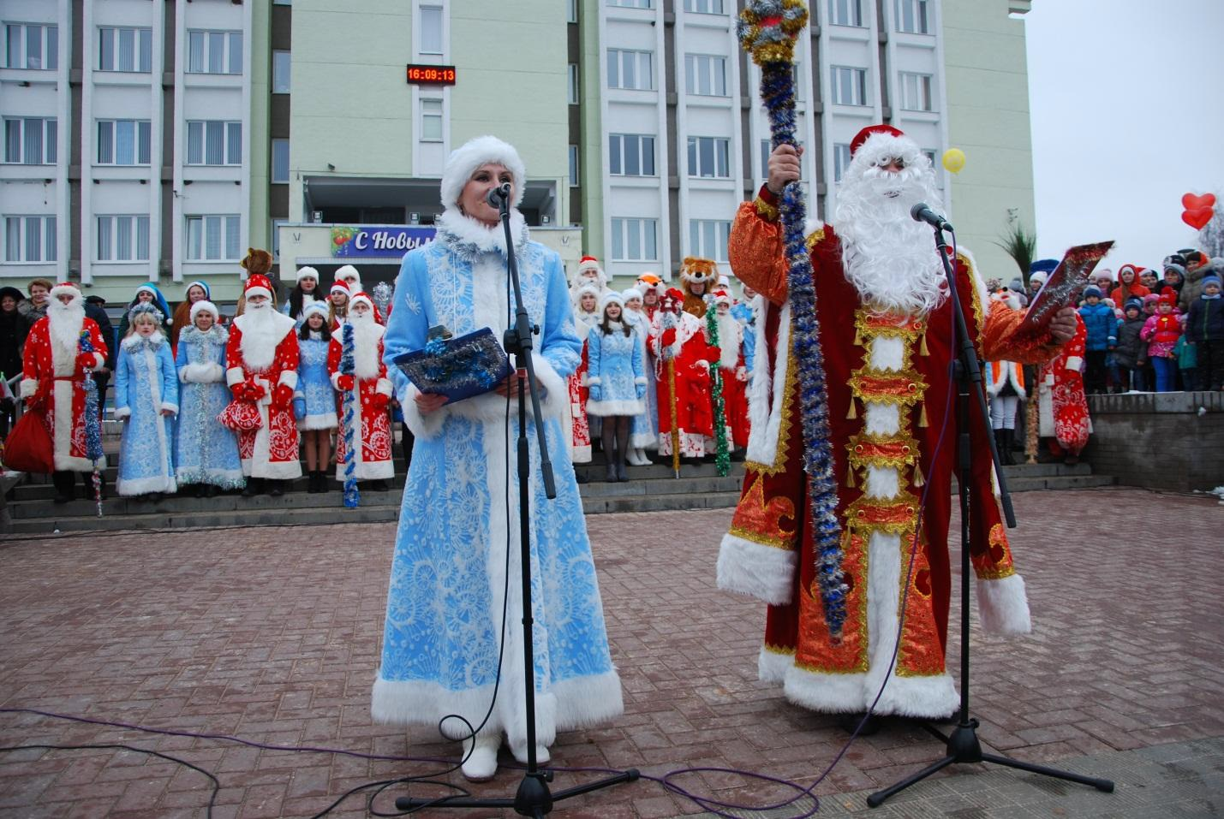 December, 21th
"The Invasion of Santa Clauses-2019”
Festive inclusion of the New Year's illumination (Slonim)
Annually, on the central square of Slonim, we turn on the New Year's illumination. Usually it goes with the participation of fairy-tale characters and the main characters of the New Year holidays -- Father Frost and Snow Maiden. The program of the holiday will include: a theatrical procession of Santa Clauses, Snow Maidens and fairy-tale heroes by the route: Pervomayskaya str.—the central square, the parade of decorated vehicles, competition of the most powerful Santa Claus and singing Snow Maiden, the best music card, festive ceremony of turning on of the New Year illumination on the main New Year tree of the town, a festive concert.

Phone: +3751562 50636

